**MBB S/N 002 incoming inspection**

* Slightly crooked resistors flagged as process indicators. Side overhang is >0 but <25%.

R31

* U10 is crooked. Within spec?
* C95 slightly excess solder, appears to be hand-soldered
* Connections not shiny – appears to be flux residue.
* Capacitor polarities good?
* IC orientations good
* Diode polarities good?
* Drill alignment good

Install ____

Install ____

Install ____

Install ____

Clean board of flux residue ______

11/16/2020 DKH

1. Install Wedgelocks with 100° screws (for now)
   1. Head well below board surface
2. Install MDM-51PBR at J3
   1. Use 2 x 2-56 x 1/4” screws and #2 NAS620 flat washers
   2. Tighten finger tight. DO NOT SOLDER
3. Install DB15-F at J5
   1. WARNING – connector not attached to plastic piece
   2. Use 2 x NAS1101-04-6 screws, no washer on front
   3. Tighten finger tight, DO NOT SOLDER
4. Install front panel using jackposts on J3 and J5
   1. None of the jackposts in my junk drawer fit for J3. Use screws for now.
5. Install in alignment fixture
   1. Does not fit – C297, C298 hit the HKB faceplate
      1. Replace C297, C298 with AVX TPME107K020R0035
         1. Use Metcal Hot Tweezers to remove existing caps
         2. Install new caps with polarity as shown

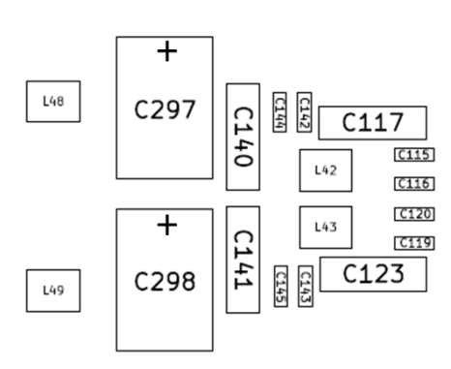

* + - 1. Clean and Inspect

1. Tighten wedgelocks
2. Tighten jackposts
3. Tighten connector screws
4. Solder J3 and J5
5. Assign CARD # __________1________________
6. Assign BOARD ID __0x6A Install ID6, 5, 3, 1___
7. Clean and Inspect
8. Install jumpers on J1
   1. These will be solder jumpers on flight boards
9. Smoke Test
   1. Resistance tests on J4 (Fluke 8060A, 20K range)

|  |  |  |
| --- | --- | --- |
| + | - | Reading |
| +5V | GND | OPEN |
| +3.3 | GND | OPEN |
| +9 | GND | OPEN |
| GND | -9 | OPEN |
| +28 | GND | OPEN |

* 1. Connect current limited power to +5, +9, -9, +28 on J4
  2. Jumper power supply ground to ground pins on J2 (Murata has isolated ground)
  3. Turn on power
     1. +5 current ________50mA_______________
     2. ±9 current _____+9 @ 50mA, -9 @ 50mA__________________
     3. +28 current ________0______________
     4. Measure +3.3V _____3.33_________________
     5. Measure +5V_DRV _____+5.0_________________
     6. Measure -5V_DRV _____-4.99_________________
  4. PASS _______DKH_____________

1. Remove front panel

# Mate/Demate Log

|  |  |  |  |  |
| --- | --- | --- | --- | --- |
| Connector | M / D | Date | Initial | Comments |
|  |  |  |  |  |
|  |  |  |  |  |
|  |  |  |  |  |
|  |  |  |  |  |
|  |  |  |  |  |
|  |  |  |  |  |
|  |  |  |  |  |
|  |  |  |  |  |
|  |  |  |  |  |
|  |  |  |  |  |
|  |  |  |  |  |
|  |  |  |  |  |
|  |  |  |  |  |
|  |  |  |  |  |
|  |  |  |  |  |
|  |  |  |  |  |
|  |  |  |  |  |
|  |  |  |  |  |
|  |  |  |  |  |
|  |  |  |  |  |
|  |  |  |  |  |
|  |  |  |  |  |
|  |  |  |  |  |
|  |  |  |  |  |
|  |  |  |  |  |
|  |  |  |  |  |
|  |  |  |  |  |
|  |  |  |  |  |
|  |  |  |  |  |
|  |  |  |  |  |
|  |  |  |  |  |
|  |  |  |  |  |
|  |  |  |  |  |
|  |  |  |  |  |
|  |  |  |  |  |
|  |  |  |  |  |
|  |  |  |  |  |
|  |  |  |  |  |
|  |  |  |  |  |
|  |  |  |  |  |
|  |  |  |  |  |
|  |  |  |  |  |